Jacob Graessle
Incident Response Forensics
Michael Zambotti

lab Eight
4/6/2025
Abstract
Lab Eight focuses on analyzing data on emails and strategies that attacker’s use of phishing emails.

Report

Objective of the Lab
The instructions for Lab Eight were to complete Phishing Analysis Fundamentals and Phishing Emails in Action on TryHackMe. The user learned the basics of emails, how they are sent, what ports they use, and different types of phishing. Different phishing types had different strategies, and the user learned how to identify these strategies.

Introduction
Spam and phishing are common social engineering attacks, often targeting users through email. Spam has existed since 1978 and continues to be a problem well into the 21st century. Phishing, a more serious threat, can lead to attackers gaining access to a network if a user clicks on a malicious link or attachment. Although security tools exist, some malicious emails still get through, and it’s essential for security analysts to analyze email headers and gather information to prevent future attacks

Process and Analysis:

Phishing Analysis Fundamentals

Task 1: Introduction

Start the VM and no answer is required.

Task 2: The Email Address

Ray Tomlinson, who invented email and popularized the use of the @ symbol, revolutionized communication in the 1970s with ARPANET. An email address consists of a user mailbox (or username), the @ symbol, and a domain. For example, in the address [billy@johndoe.com] "billy" is the user mailbox, "@" is the separator, and "johndoe.com" is the domain. This is like how a street name and house number direct a postal worker to the correct mailbox. Next, the user will explore the network protocols used to send an email.

Email dates to what time frame?
- 1970s

Task 3: Email Delivery

When you send an email, several protocols work together behind the scenes. SMTP (Simple Mail Transfer Protocol) handles sending emails, while POP3 (Post Office Protocol) and IMAP (Internet Message Access Protocol) manage the retrieval of emails. POP3 downloads emails to one device, whereas IMAP syncs emails across multiple devices. Each protocol has specific ports numbers. Images were found on the website link below.

https://help.dreamhost.com/hc/en-us/articles/214918038-Email-client-configuration-overview

What port is classified as Secure Transport (STARTTLS) for SMTP?
- 587
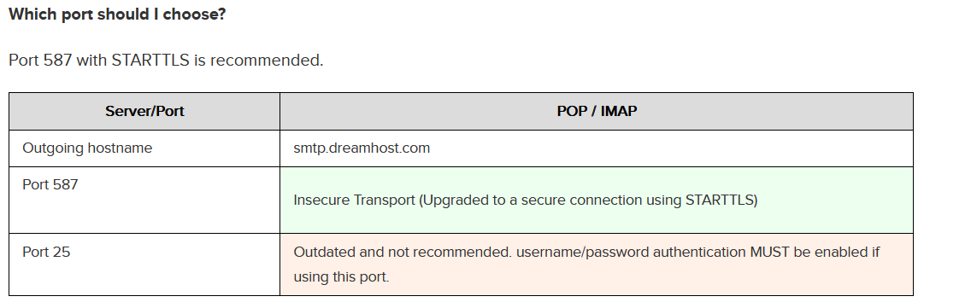
Figure 1.1: Screenshot of POP/IMAP and descriptions for port 587 and 25
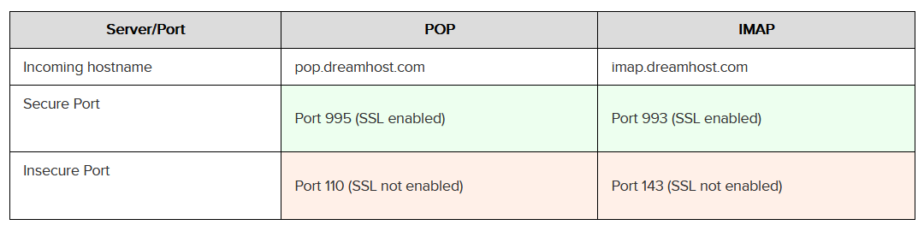
Figure 1.2: Screenshot of POP/IMAP and descriptions for port 587 and 25
What port is classified as Secure Transport for IMAP?
- 993
What port is classified as Secure Transport for POP3?
- 995

Task 4: Email Headers

To analyze a potentially malicious email, it's important to understand the two main components: the email header and the body. The header provides crucial information about the email's origin and the servers it passed through, while the body contains the actual message content.

When analyzing email headers, the key fields to examine are the "From" field, which shows the sender's email address; the "Subject" field, which indicates the subject of the email; the "Date" field, showing when the email was sent; and the "To" field, which lists the recipient's email address.

You can also view the raw email headers for more detailed information, such as the "X-Originating-IP," which reveals the sender’s IP address, the "Smtp.mailfrom/header.from" field, which shows the domain the email was sent from, and the "Reply-To" field, which indicates where replies should be sent, often different from the "From" address.

By analyzing these fields, you can start identifying suspicious elements, like mismatched "From" and "Reply-To" addresses. For further guidance on interpreting these headers, additional resources are available to help you understand the details.

https://web.archive.org/web/20221219232959/https://mediatemple.net/community/products/all/204643950/understanding-an-email-header

What email header is the same as "Reply-to"?
- return-path
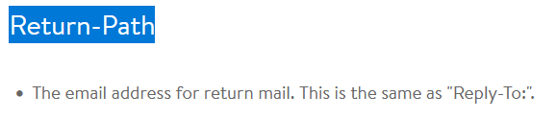
Figure 2.1: Screenshot of Return-Path with description
Once you find the email sender's IP address, where can you retrieve more information about the IP?
- http://www.arin.net
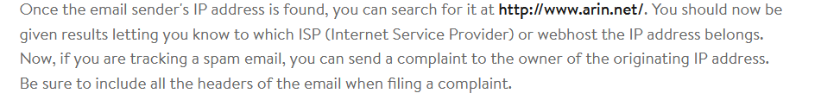
Figure 2.2: Screenshot with description of what actions to take when the sender’s IP is found

Task 5: Email Body

The email body contains the sender’s message, which can be plain text or HTML formatted. HTML emails allow for elements like images and hyperlinks. To view an email's HTML code, you can use options like "View rendered HTML" in clients like Protonmail.

Emails may also have attachments, which can be seen in HTML or source code. For example, a Yahoo email from Netflix might have a PDF attachment, with headers like "Content-Type" (application/pdf) and "Content-Disposition" (attachment). Always be cautious when handling attachments to avoid accidental opening.

In the above screenshots, what is the URI of the blocked image?
- https[:]//i.imgur[.]com/LSWOtDI.png

In the screenshots above, what is the name of the PDF attachment?
- Payment-updateid.pdf

In the attached virtual machine, view the information in email2.txt and reconstruct the PDF using the base64 data. What is the text within the PDF?
- Export the Base64 code into cyberchef. Export the results into a PDF.
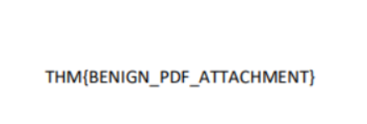
Figure 3.1: Screenshot of PDF file that contains the flag for Task 5

Task 6: Types of Phishing

Malicious emails can be classified into different types, including Spam, Phishing, Spear phishing, Whaling, Smishing, and Vishing. Spam consists of unsolicited bulk emails, while MalSpam is a more malicious version. Phishing attempts to trick recipients into providing sensitive information by masquerading as a trusted entity. Spear phishing targets specific individuals or organizations, while Whaling focuses on high-level executives. Smishing targets mobile devices with text messages, and Vishing uses voice calls for similar social engineering attacks.

Phishing emails often share common traits, such as email spoofing (masquerading as a trusted sender), urgent subject lines or content, and poorly formatted or generic email text. They may also use shortened URLs, misleading attachments, or links to malicious websites. When dealing with hyperlinks or attachments in suspicious emails, it's important to "defang" them, making them unclickable to prevent accidental clicks that could lead to a security breach.

What type of entity is this email masquerading as?
- Take the Base64 string from the "From" part of the raw data.
- Home Depot
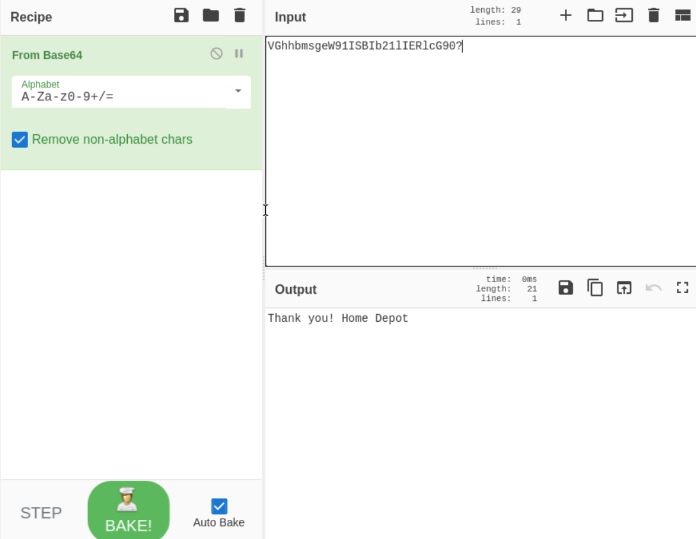
Figure 4.1: Cyberchef screenshot of Base64 string converted into readable text string
What is the sender's email?
- support@teckbe.com

What is the subject line?
- Same as the first question in this task...
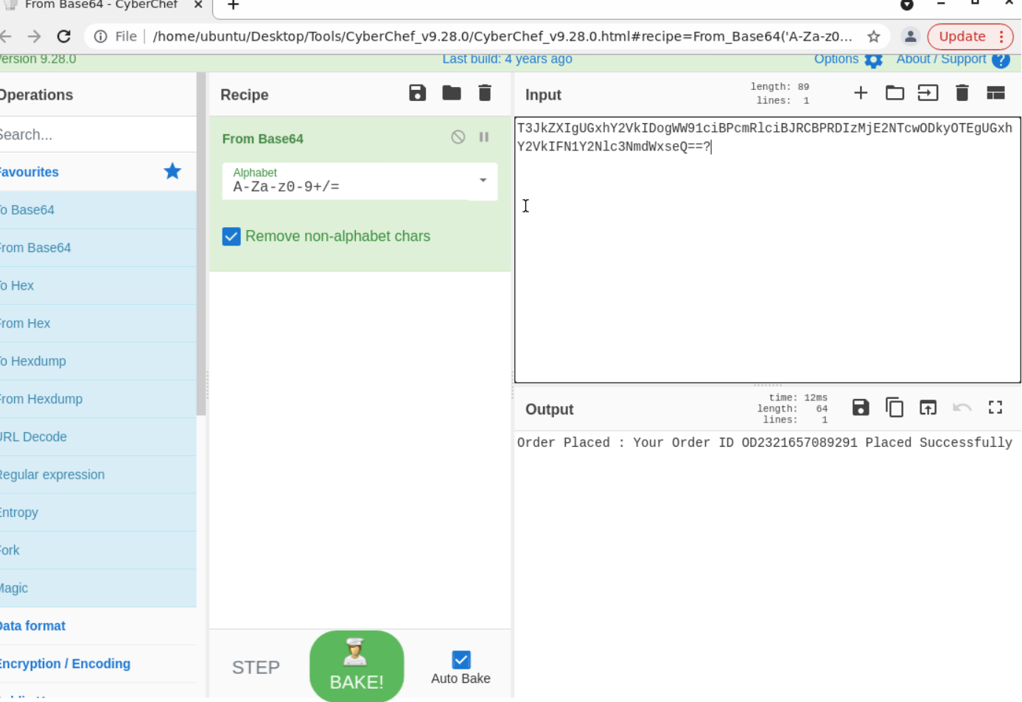
Figure 4.2: Cyberchef screenshot of Base64 subject line converted into readable text string
- Order Placed: Your Order ID OD2321657089291 Placed Successfully

What is the URL link for - CLICK HERE? (Enter the defanged URL)
Figure 4.3 Screenshot of raw data that translates to the URL
- Defang the URL in Cyberchef
hxxp[://]t[.]teckbe[.]com/p/?j3=EOowFcEwFHl6EOAyFcoUFV=TVEchwFHlUFOo6lVTTDcATE7oUE7AUET== (DEFANGED URL)

Task 7: Conclusion

It's important to understand BEC (Business Email Compromise), where attackers gain control of an employee’s email to trick others within the organization into performing unauthorized actions.

In this room, the user learned the components of an email address, how emails travel, how to view email headers and body source code, and key information to analyze when reviewing an email. We also covered common phishing techniques.

What’s BEC?
- Business Email Compromise

Phishing Emails in Action

Task 1: Introduction

In this room, the user will go through phishing email samples. The user will learn different strategies that adversaries use against victims. No answer is needed.

Task 2: Cancel your PayPal order

The user will look at spoofed emails, URL shorteners, and HTML impersonation.

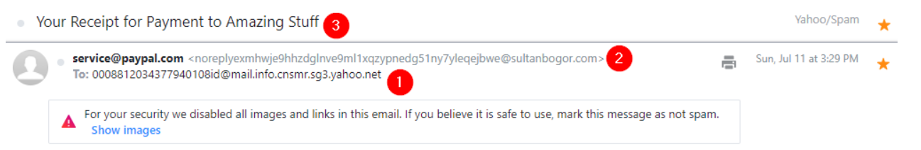
Figure 5.1: PayPal phishing email with strange noreply address
In the photo above we see that the email looks strange. The recipient’s address is not associated with the Yahoo account and the sender's details do not match the sender's email address. The email has also been flagged.

The email wants the user to click on the "cancel order" button to phish their personal data.

What phrase does the gibberish sender email start with?
- noreply

Task 3: Track your package

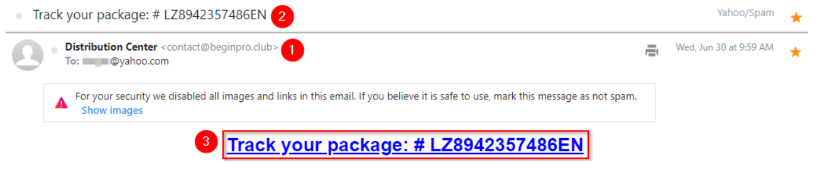
Figure 6.1: Phishing email persisting that the user click on the “Track your package” link
In this screenshot, we see that the email is from a mail distribution center. Yahoo has already flagged it. In the hyperlinks, we find that the phisher has embedded tracking pixels into the email.

What is the root domain for each URL? Defang the URL.
- devret[.]xyz

Task 4: Select your email provider to view document

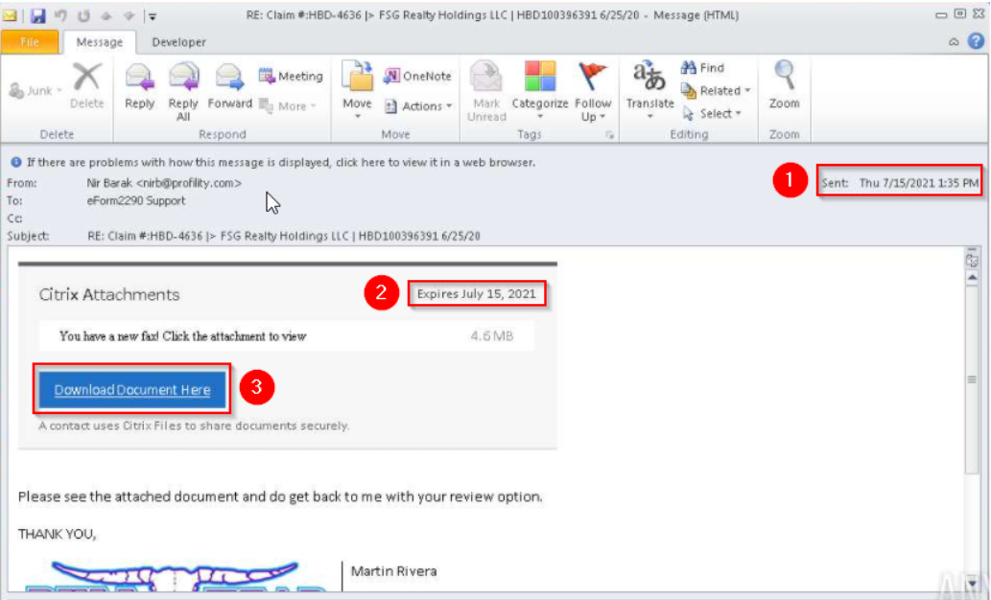
Figure 7.1: Phishing email that urges the user to download a file
This email has a sense of urgency because of the expiration data and big blue download button. After downloading the file and looking at the fax image, the user is prompted to enter credentials in a login page. No matter what the use puts in the credentials, it will be labeled as invalid. The credentials are then harvested by the attacker.

This email sample used the names of a few major companies, their products, and logos such as OneDrive and Adobe. What other company name was used in this phishing email?
- Citrix

Task 5: Please update your payment details
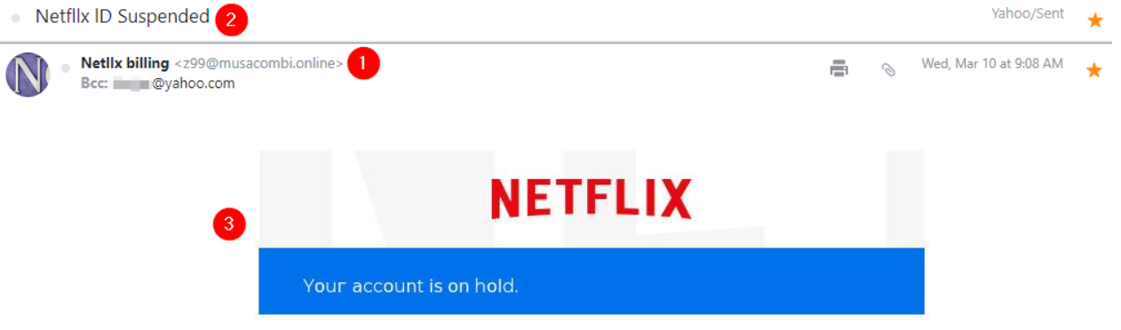
Figure 8.1: Phishing email pretending to be Netflix. Netflix is misspelled next to the email address
This one is almost obvious because Netflix is misspelled in the username of the email sender.

What should users do if they receive a suspicious email or text message claiming to be from Netflix?
- https://www.consumeraffairs.com/news/police-warn-of-new-netflix-email-phishing-scam-121718.html
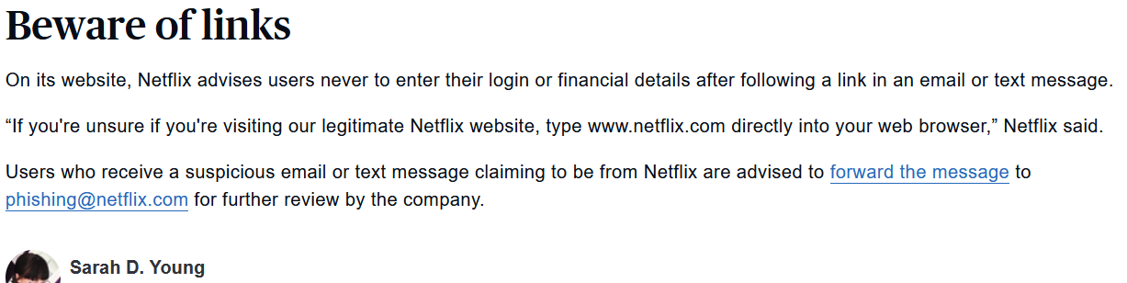
Figure 8.2: Consumer affairs article warning of Netflix phishing email
- forward the message to phishing@netflix.com

Task 6: Your recent purchase

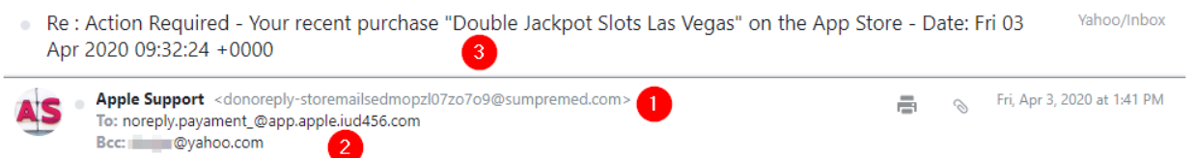
Figure 9.1: Apple Support email intending to trick the user that their account information was stolen
There are obvious misspellings sprinkled throughout the phishing email above. The sender wants the user to click on a .dot file. There is a sense of urgency as well.

What does BCC mean?
- Blind Carbon Copy

What technique was used to persuade the victim to not ignore the email and act swiftly?
- Urgency

Task 7: DHL Express Courier Shipping notice
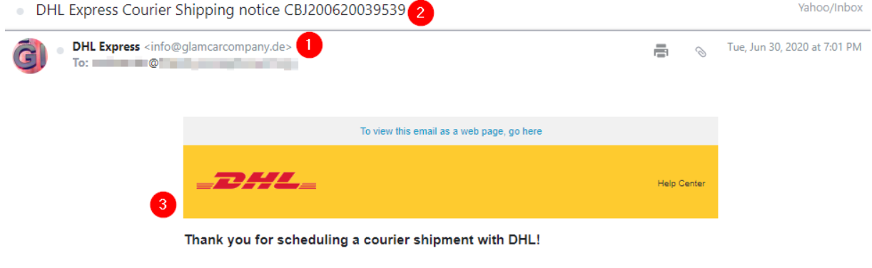
Figure 10.1: DHL phishing email with spoofed email address
This email sample demonstrates techniques like using a spoofed email address, HTML to impersonate a legitimate brand, and attachments. The sender's email doesn't match the company being impersonated, DHL, and the subject line suggests a package is being shipped by DHL. The HTML in the email body is designed to appear as though it came from DHL. Upon inspecting the source code, it's clear that the link to view the email as a web page doesn't lead to a real destination URL.

What is the name of the executable that the Excel attachment attempts to run?
- regasms.exe

Task 8: Conclusion

This concludes with the Phishing Emails in Action room.

Tools and Resources Used
- DreamHost - https://help.dreamhost.com/hc/en-us/articles/214918038-Email-client-configuration-overview – DreamHost has information on email protcols, ports, descriptions, and other technical information regarding emails.
- Media Temple - https://web.archive.org/web/20221219232959/https://mediatemple.net/community/products/all/204643950/understanding-an-email-header – With the help of the Way Back Machine, this website has information on understanding emails.
- Consumer Affairs - https://www.consumeraffairs.com/news/police-warn-of-new-netflix-email-phishing-scam-121718.html - In Task 5, this news page was used to find a specific phrase that warned Netflix users what to do if they received the phishing email.
- Cyberchef - https://gchq.github.io/CyberChef/ - Cyberchef is an open-source GitHub page used for encryption, decoding, and other methods that analyze data.

Challenges Encountered
No real challenges were encountered during this lab.

Results and Findings
In room one, I was able to convert the Base64 text into clear text so artifacts could be read. This process involved opening the archived emails in notepad, copying the data, and putting it through Cyberchef. The second room walked me through different phishing emails and what the attacker was trying to accomplish with their strategies.

Conclusion
In this lab, the user learned the basics of what email addresses are made of. Email ports and protocols were discussed as well. For hands on experience, the user looked at samples of phishing emails and analyzed them. As the user analyzed the emails they learned how to identify and diagnose phishing emails.

Future Improvements or Recommendations
I have no recommendations for this lab in the future.

References
FTC - https://consumer.ftc.gov/articles/how-recognize-and-avoid-phishing-scams - Information on the FTC on how to recognize phishing emails.

